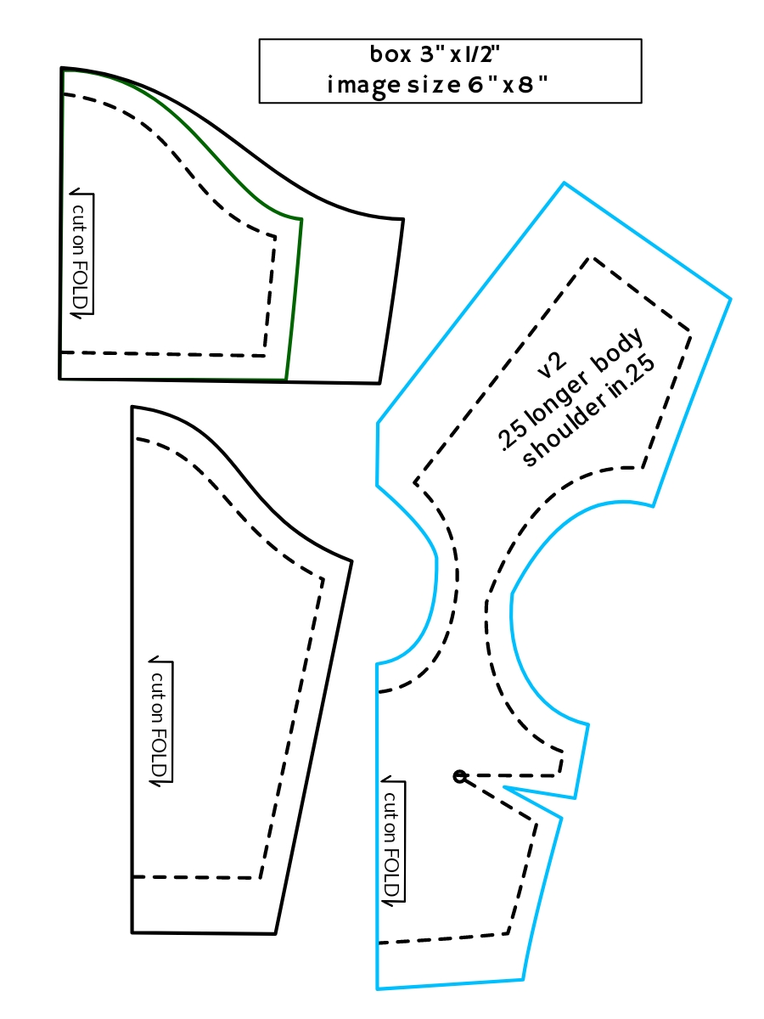The box should print 3 inches wide - "image size" was just a note to myself

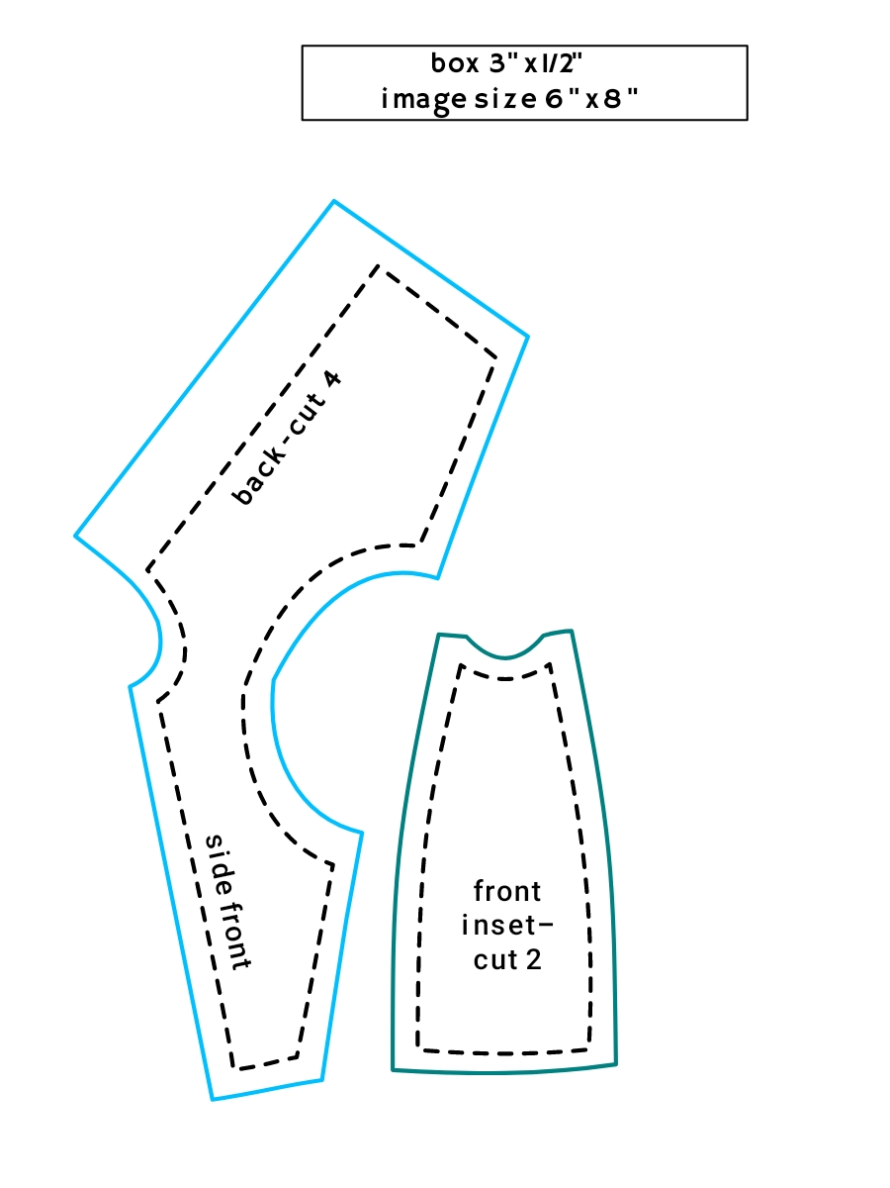

narrow seams allowed, just under 1/4" closer to 3/16"

Draft instructions - from memory - plz point out errors

(if fronts and backs weren't already cut in one piece) sew shoulder seams

(for regular pattern) sew darts in pieces separately

(for inset bodice and lining) sew the front insets to the side fronts

Place bodice pieces and lining pieces right sides together, sew up one back, around the neck and down the other back piece

Clip corners and clip close to neck stitching

Turn right sides out

Pin two bodice layers at armholes so they don't scoot

Gather sleeve tops, pin sleeves into armholes, stitch

Finish or gather the sleeve ends

(short sleeves should be gathered to 2-1/4" on the ends)

Stitch up bodice side seams and down underarm seams

Stitch skirt sections together, gather the waist, finish the back edges

Attach skirt to bodice

Add velcro

Here’s the skirt that I used for the pink test – the sides should be 7 inches long

Cut three.

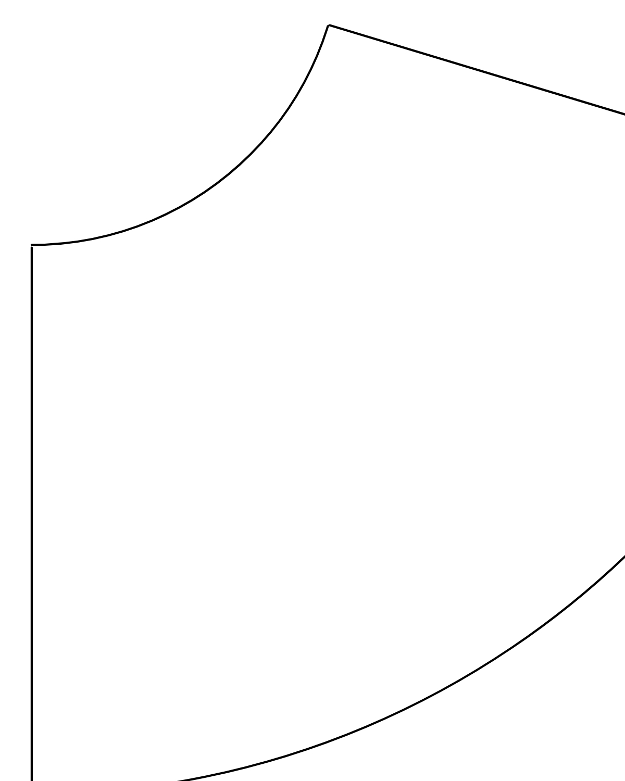

Attach another sheet and fill in the corners to   
complete the skirt piece, please :-)